Networking Concepts Guide (Part I)

* **Resource Sharing**: Networks allow multiple users to share resources like files and printers.
* **Communication**: Networks enable various forms of communication, including email, VoIP (Voice Over IP), video chats, and instant messaging.
* **Redundancy**: Networks provide data redundancy by allowing backups to be stored in different locations.
* **Internet Access**: Networks facilitate access to the internet for various activities such as checking the weather, searching information, and using social media.
* **Device Monitoring**: Networks can monitor connected devices and send alerts for issues like equipment jams or security breaches.
* **Centralized Administration**: Network administrators can manage multiple devices from a single point, eliminating the need for physical visits to each device for configuration changes.

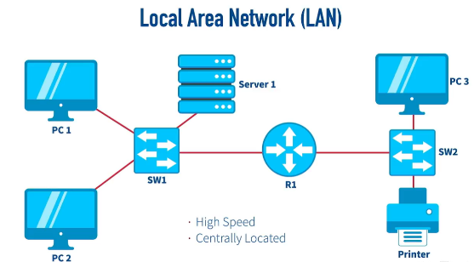

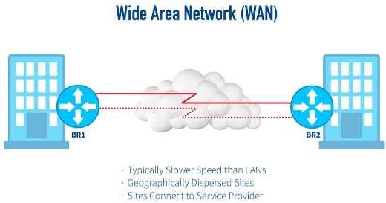

* **Local Area Network (LAN)**: High-speed networks typically within a single building or office, allowing users to access resources locally.
* **Wide Area Network (WAN)**: Interconnects geographically dispersed sites, often through service providers, and can use technologies like VPN for secure connections.
* **Metropolitan Area Network (MAN)**: Connects multiple locations within a city using high-speed fiber rings, often with redundancy.

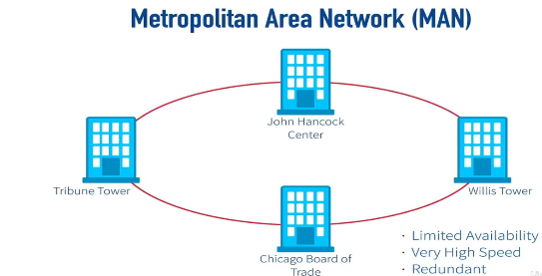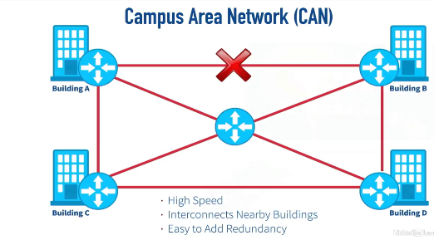

* **Campus Area Network (CAN)**: Interconnects nearby buildings within a campus, providing high-speed connections and redundancy.
* **Personal Area Network (PAN)**: Connects individual devices over short distances, often using Bluetooth.
* **Wireless Local Area Network (WLAN)**: Provides wireless connectivity through radio waves, allowing devices to communicate without physical cables.

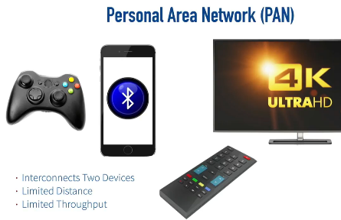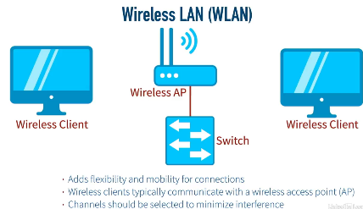

* **Physical vs. Logical Topologies**: Physical topology refers to the actual layout of the network cables and devices, while logical topology describes how data flows within the network.
* **Examples**:  
  + **Bus Topology**: Uses a single coaxial cable; only one frame can be on the wire at a time, managed by CSMA/CD.
  + **Star Topology**: Devices connect to a central hub, creating a physical star but can operate logically as a bus.
  + **Ring Topology**: Devices are connected in a ring; data passes in one direction, managed by a token.
* **Wide-Area Network Topologies**: Includes full-mesh (direct connections between all sites), partial-mesh (strategic connections based on traffic patterns), point-to-point, and point-to-multipoint topologies.